**TUGAS 2 PRAKTIKUM LAB PBO**

**Nama : Zaki Aljabbar**

**Kelas : TI – 21 – KA**

**NPM : 212310001**

1. **Latihan02.java**

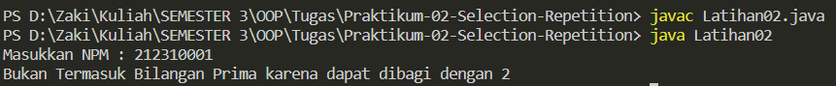

1. **Latihan03.java**

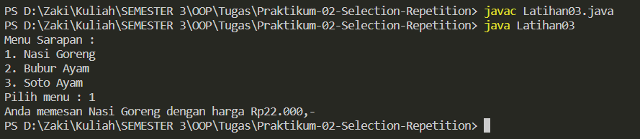

1. **Latihan04.java**

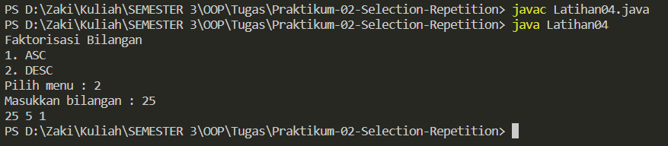

1. **Latihan05.java**

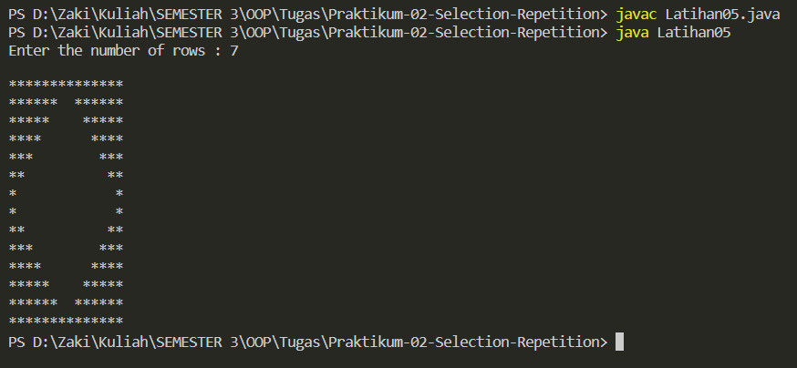

1. **Latihan06.java**

